Eval Board Lattice LC4256ZE

LED Pins:
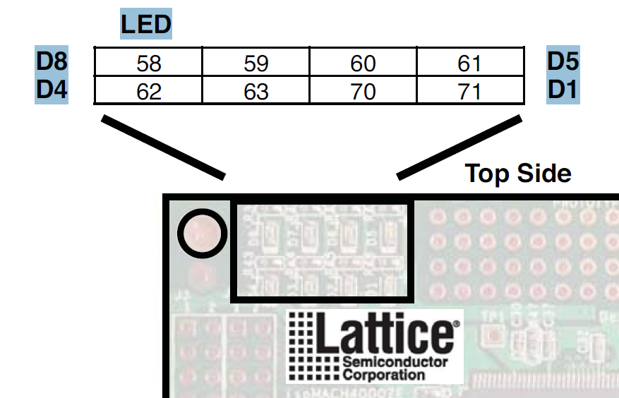

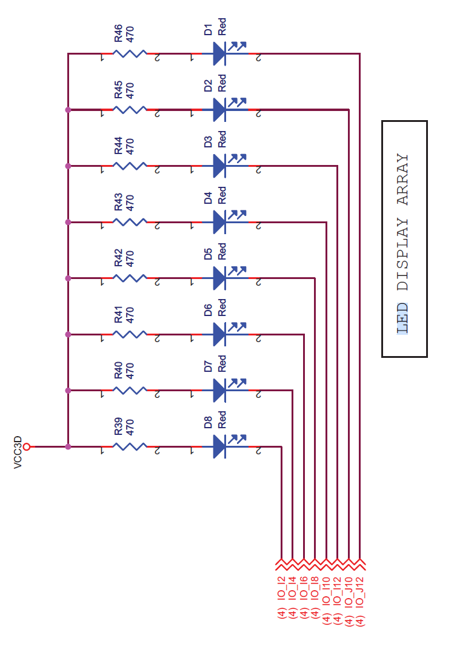

Conncet BUS signals in schematic editor:
Simply connecting them won’t work:
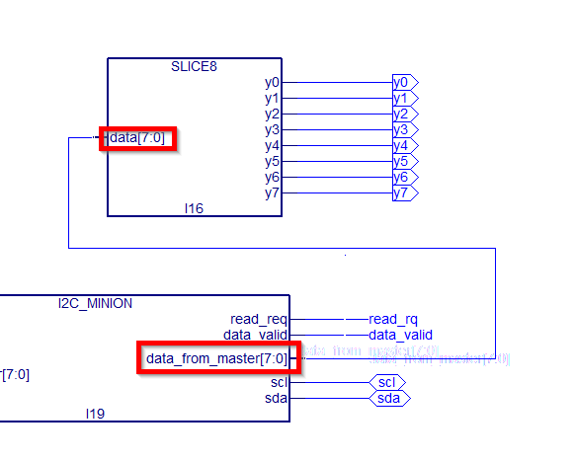

You have to add a NET name that includes the size of the bus:
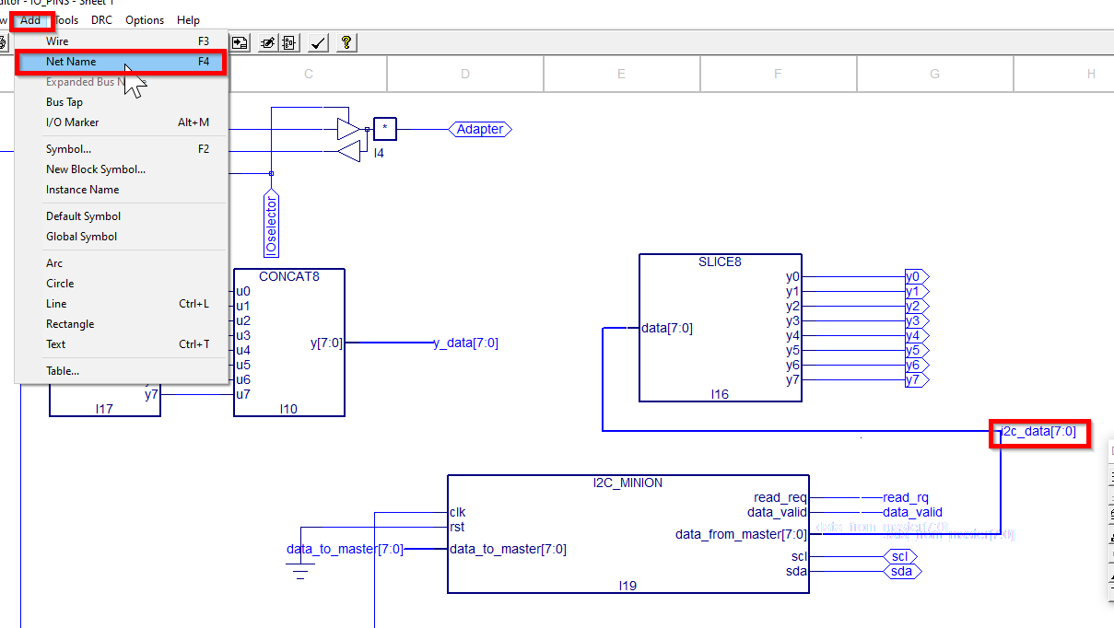
Then the bus line is automatically drawn larger. This indicates you did correctly

7-segment LED display
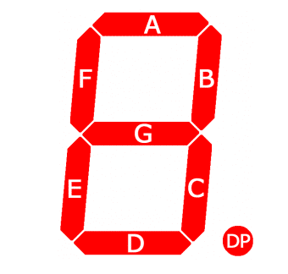
Hex | Display
06 | 1
5B | 2
4F | 3
66 | 4
6D | 5
7D | 6
07 | 7
7F | 8
6F | 9
3F | 0

